**Symbiosis Institute of Technology, Pune**

**Evaluation Plan**

Department: APPLIED SCIENCES/AIML Batch: 2023-27

Course name: Discrete Mathematics (TE7642/ 0701260410)

Credit: 03 (02+01) Year/Sem: II/IV

Max. Marks: 30 (CA) + 45 (ESE)

Name of the faculty member: Dr. Amit Kumar

|  |  |  |  |  |  |
| --- | --- | --- | --- | --- | --- |
| **Sr. No.** | **Name of Internal Component** | **COs** | **Max marks** | **Weightage** | **Tentative date** |
| **1** | Unit test | I and II | 10 (7+3) | 33.33% | 17-22 March,  2025 |
| **2** | Quiz | III and IV | 12 (6+6) | 40.00% | 22-April-2025 |
| **3** | Tutorials/Assignments | I, II, III and IV | 08 (3+1+2+2) | 36.67% | Throughout the semester (continuous assessment in tutorial sessions) |

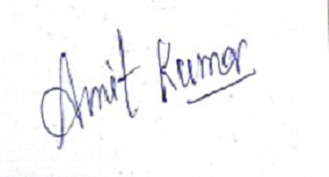

Sign of the faculty member